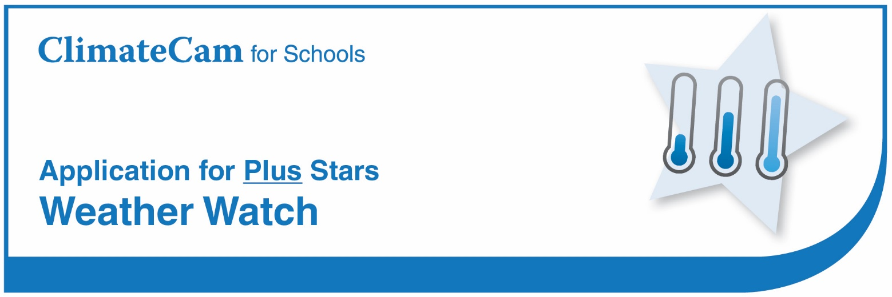

School

Star Criteria

- Collecting Weather Data at your School.
The school has collected and analysed daily weather data each day for one month including for example:
- Rainfall and if it’s a clear or cloudy day
- Maximum and minimum temperature
- Temperature at 9am and 3pm
- Wind speed at 9am and 3pm.

Evidence: Results of weather data.
- Comparing to Local Climate Data.
The school has compared and analysed average weather data for one month against the
Bureau of Meteorology climate statistics for the nearest locations including for example:
- Mean rainfall, median rainfall and mean number of days of rain ≥ 1 mm
- Number of clear days and number of cloudy days
- Mean maximum and minimum temperature,
- Mean temperature at 9am and 3pm
- Mean wind speed at 9am and 3pm.

Evidence: Results of weather data compared to climate statistics.

