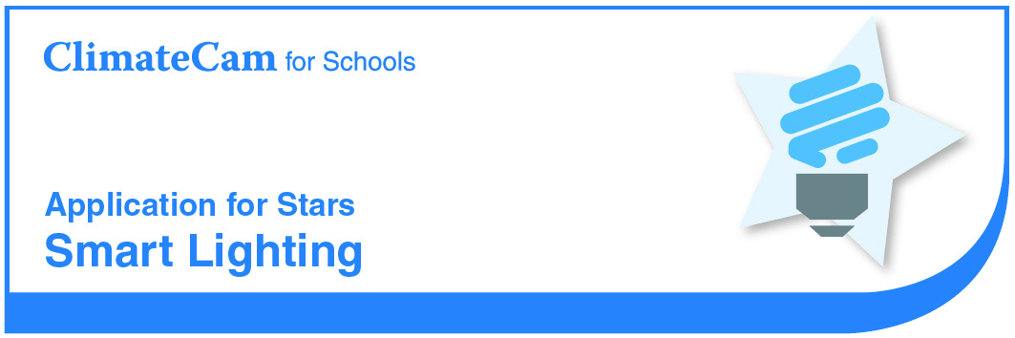

School

Star Criteria

- Conduct a Lighting Investigation or Audit
The school has conducted a lighting investigation or audit of classroom and hallways. The audit should include the number and types of lights; an estimate of the energy used (kWh) each day for lighting; and the savings that could be made / have been made by replacing lights with energy efficient models. (Note: can be completed as part of overall energy audit).
Evidence: Results of the investigation or audit, including details above.
- Implement a Smart Lighting Policy
The school has implemented a Smart Lighting Policy including education and monitoring to encourage efficient use of lighting.
Evidence: Copy of Policy and evidence of implementation (e.g. photographs and inspection checklists).
- Some Lights are Energy Efficient
The school has begun replacing classroom and hallway fittings with energy efficient models.
Evidence: Photographic evidence. The statement providing details of number of fittings that have been upgraded.

Section 1 – Lighting Audit
Activity How much energy is used for lighting at your school?
Location | Type of light fitting | Number of fittings(no.) | Watts per fitting (W) | Hours used per day (h) | kWh/fitting /day  (Wxh÷1000) | Total kWh used /day  (kWh x no.)
Classrooms
Hallways
Outdoor Walkways
Office and staff rooms
Library
Canteen
 |  |  |  |  | TOTAL
Calculate the electricity saved per year for smart lighting
Required Data
A single 28 W T5 linear fluorescent luminaire uses 32 Watts per fitting (including ballasts).
Calculations
Usage from single T5 fittings = number of fittings x 32 watts x hours (average usage per day)
= kWh per day
Electricity savings per day = (Estimated school usage) — (Usage from single T5 fittings)
= kWh per day
Electricity saved per year = kWh per day x 200 days = kWh per year
Result
Our lights use approximately kWh per year.

Section 2 – Implementation of Smart Lighting Policy
* Insert or attach your Smart Lighting Policy
Tell us how your Smart Lighting Policy has been implemented.

Section 3 – Some Lights are Energy Efficient

* Insert or attach photographic evidence

Number of fittings replaced:
Lighting Type:
Date of upgrade: | (if known)

