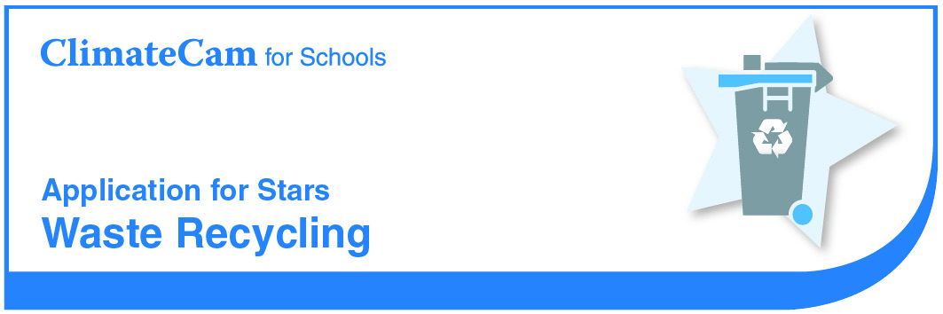

School

Star Criteria
- Conduct a Waste Audit The school has conducted a waste investigation or audit categorizing different types of waste produced in a day and detailing weight and volume for each type of waste.
Evidence: Results of the waste audit, including photographic evidence.
- Paper and Cardboard Recycling The school has implemented regular paper and cardboard recycling.
Evidence: Photographic evidence
- Recycling of Organics The school has implemented a recycling program for a portion of the school’s organic waste, including composting, worm farming and/or using scraps as a food stock for animals, such as chickens.
Evidence: Photographic evidence and details of what organic waste is recycled, how often, and an estimate of quantity recycled.
- Waste-Free Lunches The school has held a waste-free lunch, and must commit to holding at least one waste-free lunch per year.
Evidence: Copies of information advising parents of the waste-free lunch and details of how frequently waste-free lunches will be held.

Section 1 – Conduct a Waste Audit

* Insert or attach results of waste investigation or audit. Categorise the different types of waste produced in a day and weight and/or volume for each type of waste.

* Insert or attach photographs of waste audit.

Section 2 – Paper and Cardboard Recycling

What materials are recycled in the school (e.g. paper, cardboard, plastic bottles)?
Where are recyclables collected from (e.g. canteen, staffroom, classrooms, playground)?
* Insert or attach photographic evidence of paper and cardboard recycling (classroom and outside bins).

Section 3 – Recycling of Organics

What organics are recycled in the school?
How often is this recycled?
How are they recycled?
Approximately how much is recycled per year?
How is the product used in the school?
* Insert or attach photographic evidence or organics recycling.

Section 4 – Waste-Free Lunches

When was your waste-free lunch held?
Who was involved? (whole school / year group)
How often do you hold waste free lunches?
How often do you plan to hold waste-free lunches in the future?

* Insert or attach evidence such as notes to parents or newsletter stories.

