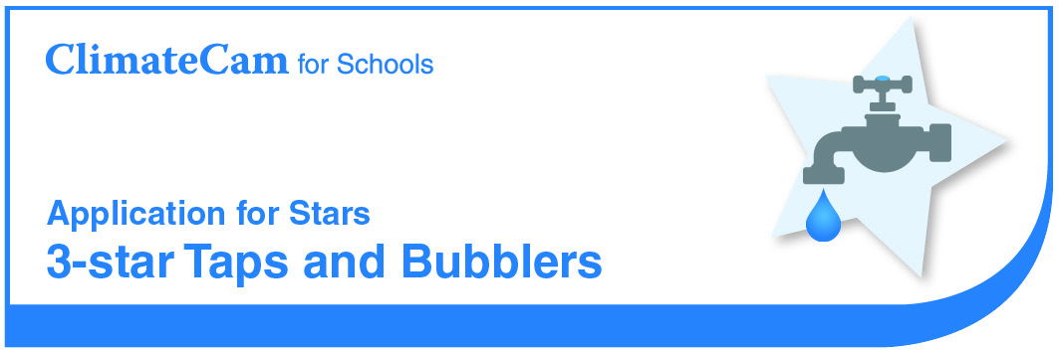

School

Star Criteria
- Audit of Taps and Bubblers
The school has conducted an audit detailing: number of fittings; details of leakages; and savings which could be / have been made by replacing fittings with water efficient models. (Note: this can be undertaken as part of a water audit).
Evidence: Results of the audit, including all details above.
- Repair of Leaking Taps and Bubblers. The school has implemented procedures to report and repair leaking taps and bubblers.
Evidence: Copy of procedure and evidence that it is being implemented (e.g. inspection checklist, repair logs).
- All Bubblers and Student Amenity Block Taps are 3 Star The school has begun replacing bubblers and amenity block taps with 3 star or above and may be spring loaded or push button. The school must also have calculated the savings made by replacing taps and bubblers with water efficient models.
Evidence: Photographic evidence A statement detailing the number of taps and bubblers replaced and calculated water savings made.

Section 1 - Audit of Taps and Bubblers Results

Fitting | Number | Standard or spring loaded | Number leaking | Flow rate of leaks⁺ (L/min)
Bubblers
Student amenity block taps (inside and out)
Classroom taps
Outside taps
Other taps
Activity

Savings made for hand washing by installing water efficient taps
Time to wash our hands: minutes
Number of students and teachers:
Required Data
Assume each person washes their hands 3 times a day
Inefficient taps have a flow rate of about 16 litres/minute.
Efficient taps have a flow rate of less than 8 litres/minute.

Water used - inefficient taps = 3 washes x number people x 16L x 1 minute x 200 days = Litres (A)
Water used - efficient taps = 3 washes x number people x 8L x 1 minute x 200 days
= Litres (B)
Result
Water saved by installing water efficient taps is A – B = Litres

Section 2 - Repair of Leaking Taps and Bubblers

What procedure exists to identify and report leaking taps or bubblers?

* Insert or attach evidence (e.g. inspection checklist or General Assistant repair logs)

Section 3 - All Bubblers and Amenity Block Taps are 3 Star

We confirm that our school has begun upgrading taps and bubblers in student amenity blocks to water efficient (3 Star Rated) models. Information relating to the upgrade is included below.

Student Amenity Taps
Type of fittings: | e.g. Spring loaded / push button
No. of fittings replaced:
Date of upgrade:

Bubblers
Type of fittings: | e.g. Spring loaded / push button
No. of fittings replaced:
Date of upgrade:

* Insert or attach photographic evidence

